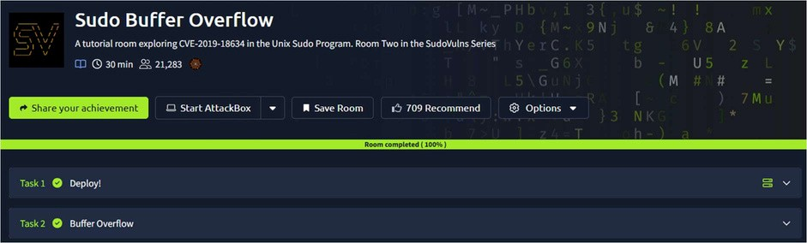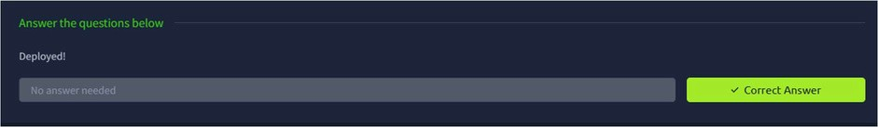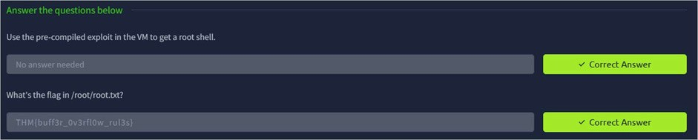
CR23431 - Network Security Lab

Aim:

To explore CVE-2019-18634 in the Unix Sudo Program.

Procedure:

Tasks:

5
. STACK BASED BUFFEROVERFLOW ATTACKS

DATE: 25/02/2026

TASK 1 – Deploy!
TASK 2 – Buffer Overflow

1
. Log into TryHackMe and open the Sudo Buffer Overflow room.

. Study the basics of buffer overflow vulnerabilities in Unix systems.
2

3
. Understand the vulnerability CVE-2019-18634 in the Sudo program.

. Analyze how improper input handling leads to memory overflow.
4

5
. Explore the steps used to identify and exploit the vulnerability in a controlled

environment.

6
. Complete the tasks and answer the questions in the room.
7
. Review mitigation techniques and confirm completion.

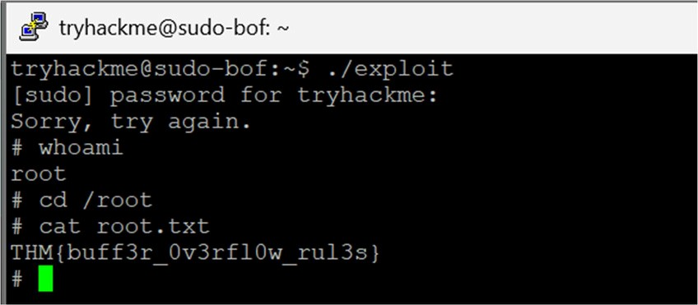
CR23431 - Network Security Lab

Result:

Thus the TryHackMe room Sudo Buffer Overflow was completed successfully.

